Solderless Breadboard Basics
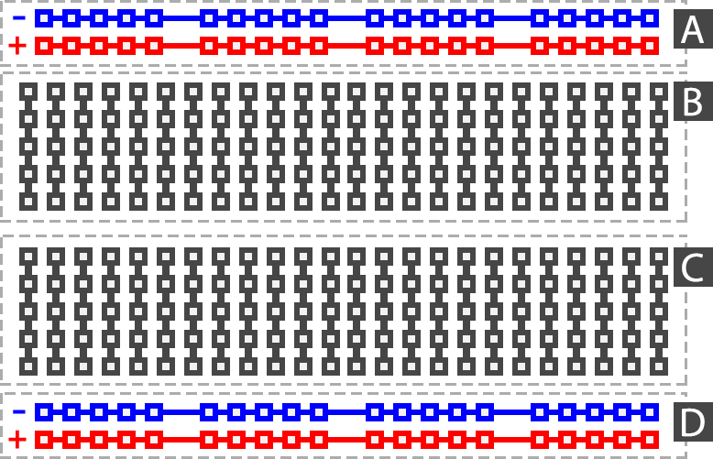
One of the most important tools for prototyping is the solderless breadboard. This is a simple device that lets us wire devices together without the need to use soldering. This lets us quickly connect devices, and easily re-wire them as the design of the hardware evolves over time. Being able to easily make changes to our hardware is an important aspect of rapid prototyping.
They key to understanding how breadboard works is understanding how they are wired. There are two long rails along the top and bottom of the board. These are typically used for ground and power, though they can be purposed however the user sees fit.

